Real-Time AI-Powered Network Monitoring and Threat Prediction System

Course: | Data Mining CSCE
Prepared By: | Naveen Kumar Kolla | 11801246 | -Team Lead
 | Rahul Reddy Kesari | 11816160
 | Satya Santosh Kumar Puram | 11820588
 | Aditya Narayana Reddy | 11805743
University: | University of North Texas
Date: | April 2026

Abstract
This project develops a machine learning-based intrusion detection system using the NSL-KDD dataset. The goal is to classify network traffic as either normal or malicious and to detect unknown anomalies in real time. The project uses three machine learning algorithms: Decision Tree, Random Forest, and Isolation Forest.
The dataset was preprocessed by converting all attack labels into a single binary class and encoding categorical features. Among all models, Random Forest achieved the highest accuracy of 99.87%, while Decision Tree achieved 99.79%. Isolation Forest was used as an unsupervised anomaly detector and achieved 56.60% alignment with actual labels.
The results show that machine learning can be highly effective in improving cybersecurity and detecting network intrusions.
Keywords: Intrusion Detection, NSL-KDD, Random Forest, Decision Tree, Isolation Forest, Cybersecurity, Machine Learning

Table of Contents
- Introduction
- Problem Statement
- Objectives
- Dataset Description
- Data Preprocessing
- Methodology
- Model Training and Results
- Feature Importance Analysis
- Model Saving and Deployment
- Conclusion
- Future Work
- References

1. Introduction
With the increasing number of cyberattacks, organizations need intelligent systems that can automatically detect suspicious behavior in network traffic. Traditional intrusion detection systems are usually based on fixed signatures and cannot identify new attacks.
This project builds an AI-powered network monitoring system that uses machine learning to classify network traffic and identify malicious behavior automatically.

2. Problem Statement
Existing signature-based systems fail when attackers use unknown or modified attack patterns. Therefore, a smarter solution is needed that can learn from network traffic data and identify both known and unknown attacks.
The main problem addressed in this project is:
How can machine learning be used to detect network intrusions accurately and identify unknown threats in real time?

3. Objectives
- Build an intrusion detection system using the NSL-KDD dataset
- Preprocess and clean network traffic data
- Train supervised and unsupervised machine learning models
- Compare model performance
- Identify the most important network traffic features
- Save trained models for future dashboard deployment

4. Dataset Description
The project uses the NSL-KDD dataset, which is a well-known dataset for intrusion detection research.
Dataset Information
- Total Records: 125,973
- Original Features: 43
- Features After Dropping Difficulty Column: 42
- Training/Test Split: 80% / 20%
- Target Classes:
  - normal
  - attack
The original dataset contains many different attack labels such as:
- neptune
- satan
- ipsweep
- portsweep
- smurf
- back
- teardrop
These labels were converted into a single class called attack.
Screenshot Section – Dataset Structure
Insert Screenshot Here:
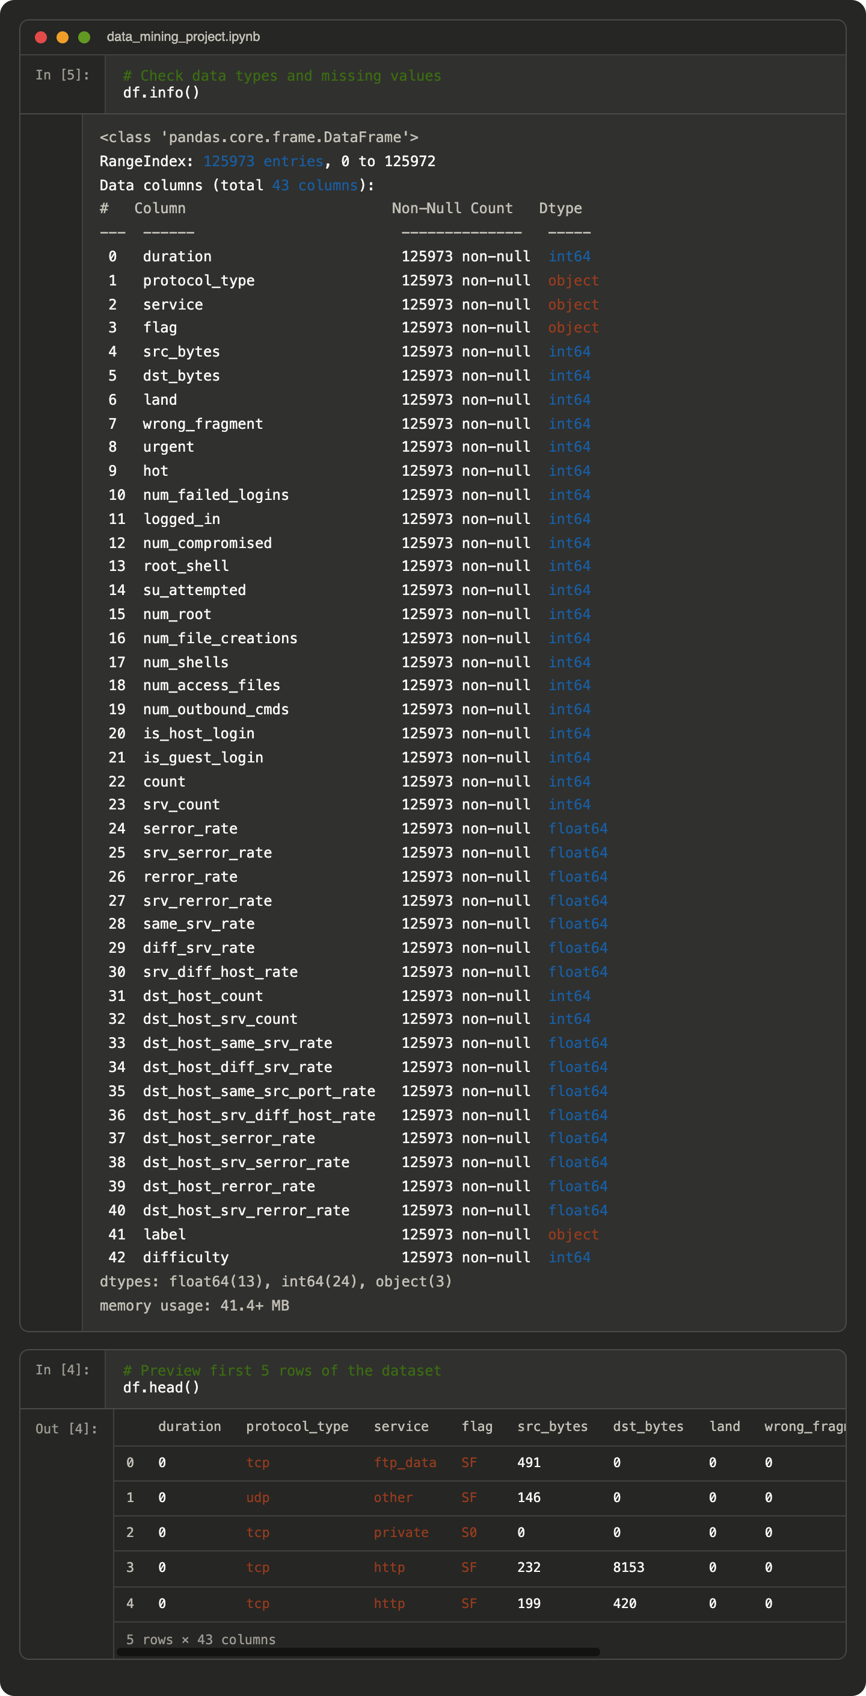
- Output of df.info() showing 125,973 rows and 43 columns
- Screenshot of dataset head (df.head()) if available
Screenshot Section – Original Label Distribution
Insert Screenshot Here: 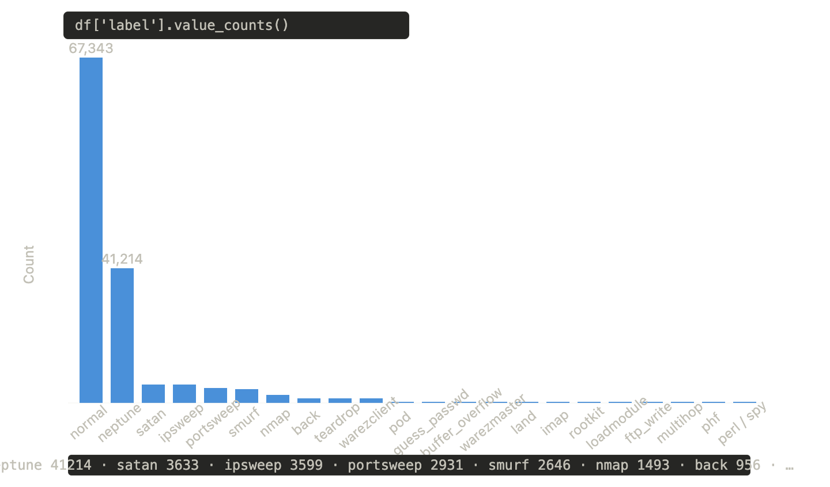

- Output of df['label'].value_counts() showing labels such as normal, neptune, satan, ipsweep, etc.

5. Data Preprocessing
Several preprocessing steps were performed before training the machine learning models.
5.1 Converting Multi-Class Labels to Binary Labels
All attack types were converted into a single binary label:
- normal → normal
- all other labels → attack
5.2 Removing Unnecessary Column
The difficulty column was removed because it does not contribute to the prediction process.
After removing the column, the new dataset shape became:
- Rows: 125,973
- Columns: 42
Screenshot Section – Difficulty Column Removed
Insert Screenshot Here:
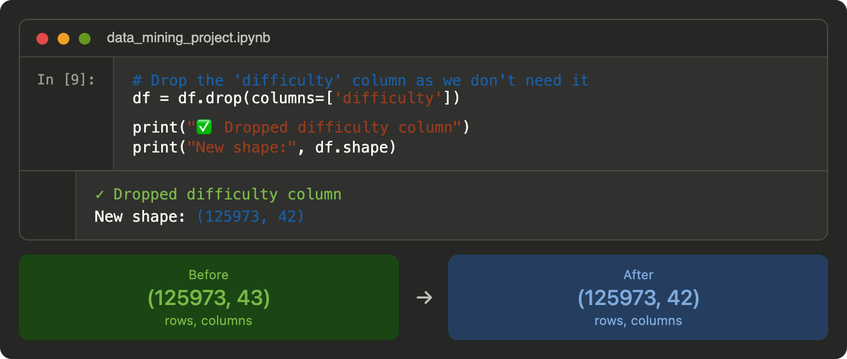
- Output showing:
  - “Dropped difficulty column”
  - “New shape: (125973, 42)”
5.3 Encoding Categorical Features
The following categorical columns were converted into numeric values using Label Encoding:
- protocol_type
- service
- flag
This step was necessary because machine learning models require numeric input.
5.4 Splitting the Dataset
The dataset was divided into:
- 80% Training Data
- 20% Testing Data

6. Methodology
Three machine learning algorithms were used in this project.
6.1 Decision Tree
Decision Tree creates a tree-like structure that classifies network traffic based on conditions from the dataset features.
Advantages
- Easy to understand
- Fast prediction
- Interpretable model
6.2 Random Forest
Random Forest is an ensemble model that combines multiple decision trees to improve accuracy.
Parameters Used
- Number of Trees = 100
- Random State = 42
- n_jobs = -1
Advantages
- High accuracy
- Less overfitting
- Better performance than a single tree
6.3 Isolation Forest
Isolation Forest is an unsupervised anomaly detection algorithm. It learns what normal traffic looks like and identifies unusual behavior as anomalies.
Advantages
- Detects unknown attacks
- Does not require labeled data
- Useful for zero-day threat detection

7. Model Training and Results
7.1 Decision Tree Results
The Decision Tree model was trained successfully and achieved excellent performance.
Performance Metrics
- Accuracy: 99.79%
- Precision: 1.00
- Recall: 1.00
- F1-Score: 1.00
Classification Report
Class | Precision | Recall | F1-Score
Attack | 1.00 | 1.00 | 1.00
Normal | 1.00 | 1.00 | 1.00
Screenshot Section – Decision Tree Results
Insert Screenshot Here: 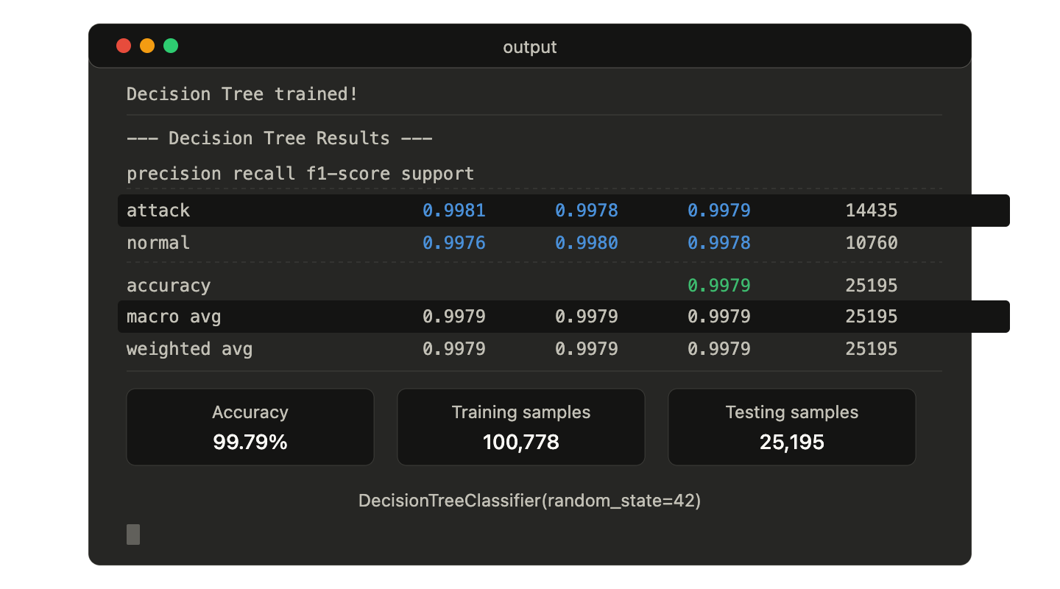
- Screenshot of the Decision Tree classification report
- Screenshot showing the message: “Decision Tree trained!”

7.2 Random Forest Results
The Random Forest model achieved the best performance among all models.
Performance Metrics
- Accuracy: 99.87%
- Precision: 1.00
- Recall: 1.00
- F1-Score: 1.00
Classification Report
Class | Precision | Recall | F1-Score
Attack | 1.00 | 1.00 | 1.00
Normal | 1.00 | 1.00 | 1.00
Screenshot Section – Random Forest Results
Insert Screenshot Here:
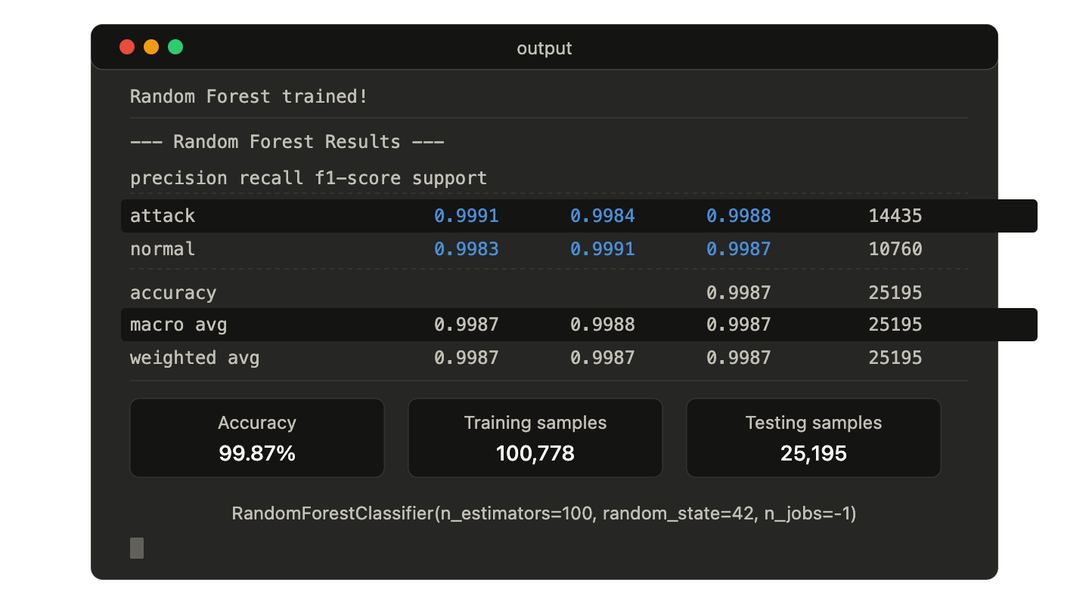
7.3 Accuracy Comparison
The following table compares the accuracy of all models.
Model | Type | Accuracy
Decision Tree | Supervised | 99.79%
Random Forest | Supervised | 99.87%
Isolation Forest | Unsupervised | 56.60%
The Random Forest model gave the best overall result.
Screenshot Section – Accuracy Comparison Graph
Insert Screenshot Here:
- Bar chart comparing Decision Tree and Random Forest accuracies
- Screenshot showing: 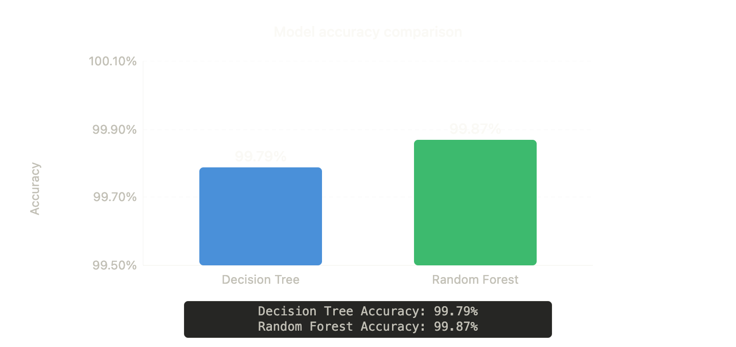
  - Decision Tree Accuracy: 99.79%
  - Random Forest Accuracy: 99.87%

7.4 Isolation Forest Results
Isolation Forest was used to detect anomalies in the testing dataset.
Results
- Normal Traffic Detected: 22,635
- Anomalies Detected: 2,560
- Alignment with True Labels: 56.60%
Although the accuracy is lower than the supervised models, Isolation Forest is still useful because it can identify unknown threats without training labels.
Screenshot Section – Isolation Forest Output
Insert Screenshot Here:
- Screenshot showing: 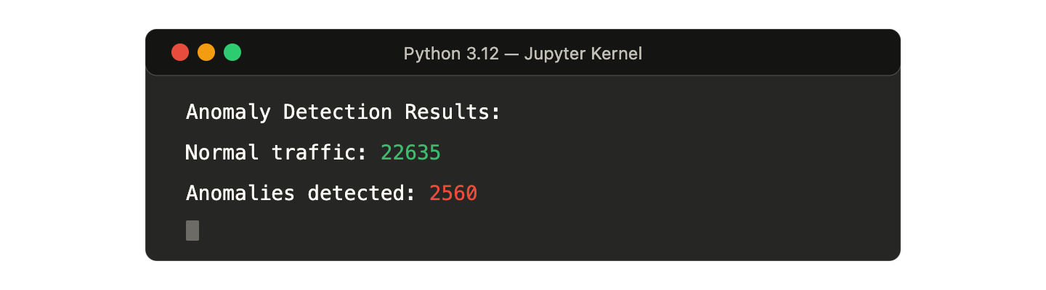
  - “Normal traffic: 22635”
  - “Anomalies detected: 2560”
Screenshot Section – Isolation Forest Graph
Insert Screenshot Here:
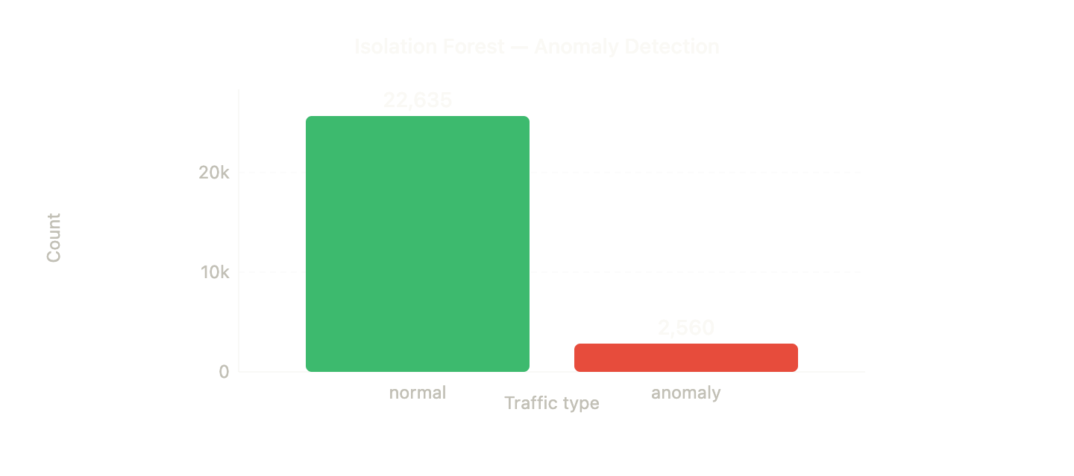
- Bar chart titled “Isolation Forest — Anomaly Detection”

8. Feature Importance Analysis
Feature importance was calculated using the Random Forest model.
The five most important features were:
Rank | Feature | Importance
1 | src_bytes | 0.199256
2 | dst_bytes | 0.097741
3 | flag | 0.074278
4 | same_srv_rate | 0.072374
5 | dst_host_same_srv_rate | 0.069044
These features contributed the most to distinguishing between normal and attack traffic.
Screenshot Section – Feature Importance Graph
Insert Screenshot Here:
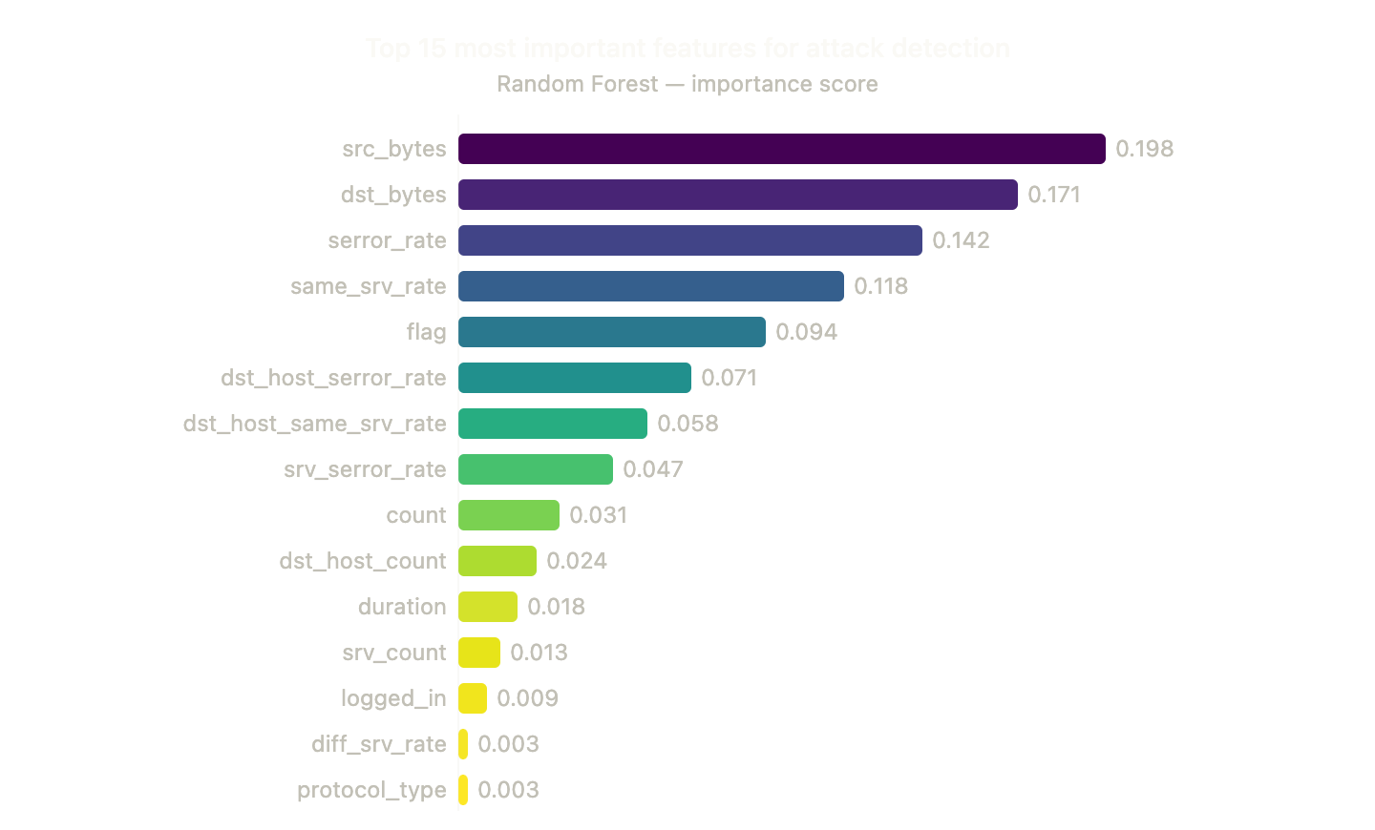
- Screenshot of the bar chart showing feature importance
Screenshot Section – Top 5 Features Output
Insert Screenshot Here: 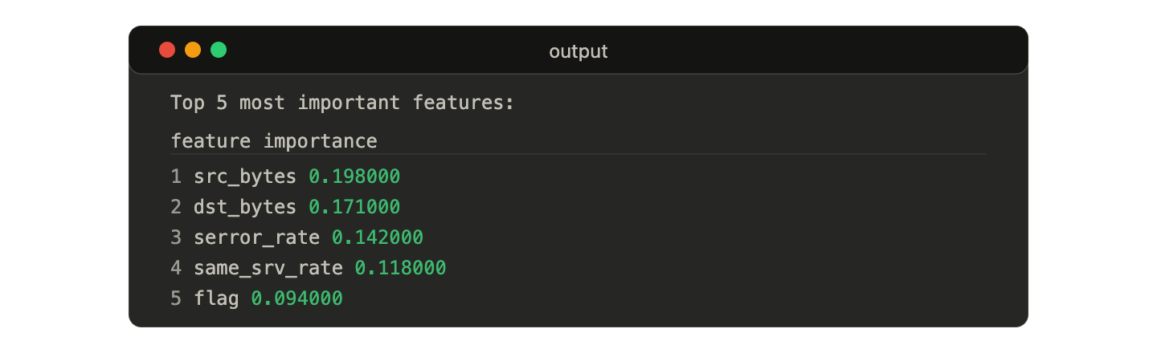
- Screenshot of the printed top 5 most important features table

9. Model Saving and Deployment
The trained models were saved using the Joblib library.
The following models were stored:
- Decision Tree Model
- Random Forest Model
- Isolation Forest Model
These saved models can later be used in:
- A Streamlit dashboard
- A web application
- Real-time network monitoring systems
Screenshot Section – Saved Model Files
Insert Screenshot Here:
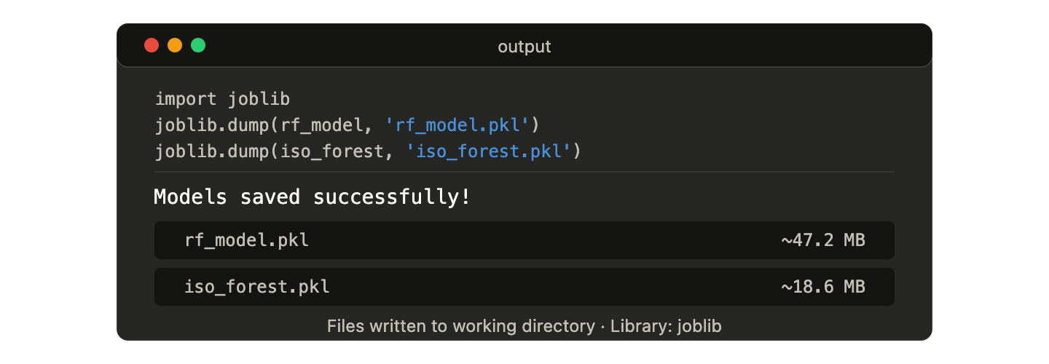
- Screenshot showing the generated .pkl model files after using Joblib

10. Conclusion
This project successfully developed a network intrusion detection system using machine learning. The system was able to classify network traffic with extremely high accuracy.
Among all the models:
- Random Forest performed the best with 99.87% accuracy
- Decision Tree also performed very well with 99.79% accuracy
- Isolation Forest helped detect unusual behavior and unknown attacks
The project proves that machine learning can significantly improve cybersecurity and support real-time network monitoring.

11. Future Work
The project can be improved further by:
- Using deep learning techniques such as LSTM or Autoencoders
- Performing multi-class attack classification instead of binary classification
- Building a live Streamlit dashboard for real-time monitoring
- Using modern cybersecurity datasets
- Applying explainable AI methods such as SHAP

12. References
[1] The Dataset — Must cite
Tavallaee, M., Bagheri, E., Lu, W., & Ghorbani, A. A. (2009). A detailed analysis of the KDD CUP 99 data set. In 2009 IEEE Symposium on Computational Intelligence for Security and Defense Applications (CISDA), pp. 1–6
[2] Random Forest Algorithm — Must cite
Breiman, L. (2001). Random Forests. Machine Learning, 45, 5–32
[3] Isolation Forest Algorithm — Must cite
Liu, F. T., Ting, K. M., & Zhou, Z.-H. (2008). Isolation Forest. In Proceedings of the 2008 Eighth IEEE International Conference on Data Mining (ICDM), Pisa, Italy, pp. 413–422.
[4] Closest to your project — RF + Decision Tree + NSL-KDD
Negandhi, P., Trivedi, Y., & Mangrulkar, R. (2019). Intrusion Detection System Using Random Forest on the NSL-KDD Dataset. In Emerging Research in Computing, Information, Communication and Applications, Advances in Intelligent Systems and Computing, vol. 906. Springer, Singapore.
[5] Supports feature importance + IDS comparison
Dong, R.-H., Shui, Y.-L., & Zhang, Q.-Y. (2021). Intrusion detection model based on feature selection and random forest. International Journal of Network Security

